Task 11

1Q.A

| **Access Modifiers** | **Within Class** | **Within Package** | **Outside Package by subclass only** | **Outside Package** |
| --- | --- | --- | --- | --- |
| **Private** | Y | N | N | N |
| **Default** | Y | Y | N | N |
| **Protected** | Y | Y | Y | N |
| **Public** | Y | Y | Y | Y |

2Q.A

| **Exception** | **Error** |
| --- | --- |
| Exception is an event that occurs during the execution of program which will cause program termination | Error is a serious problem that occurs during execution of program like syntax errors or logical errors |
| Exceptions can be handled by try_catch block | Errors can't be handled by try_catch block |
| Exceptions are classified into two types  1.checked exceptions  2.unchecked exceptions | Errors are classified into two types  1.syntax errors  2.logical errors |
| Checked Exceptions are the exceptions that are checked at compile time | If we have syntax errors, the program does not execute syntax errors are the errors like missing semicolon,braces.. |
| Un checked Exceptions are the exceptions that are checked at runtime | If we have a logical errors ,program will execute but output will be incorrect |
| Examples of Exceptions are:Array index out of bound,Arithmetic exception | Examples of Errors:out of memory,stack overflow |

3Q.A

| **Checked Exception** | **Unchecked Exception** |
| --- | --- |
| Checked Exception are checked at compile time | Unchecked Exception are checked at run time |
| Checked Exception are also called compile time exceptions | Unchecked Exception are also called run time exceptions |
| Checked Exception are identified by java compiler | Unchecked Exception are not identified by java compiler |
| Ex:FileNotFound Exception  IO Exception  Interrupted Exception etc | Ex:Arithmetic Exception  NullPointer Exception  ArrayIndexOutOfBound etc |
| Checked Exceptions are handled by throws keyword | Unchecked Exceptions are not handled by throws keyword |

4Q.A

Output:

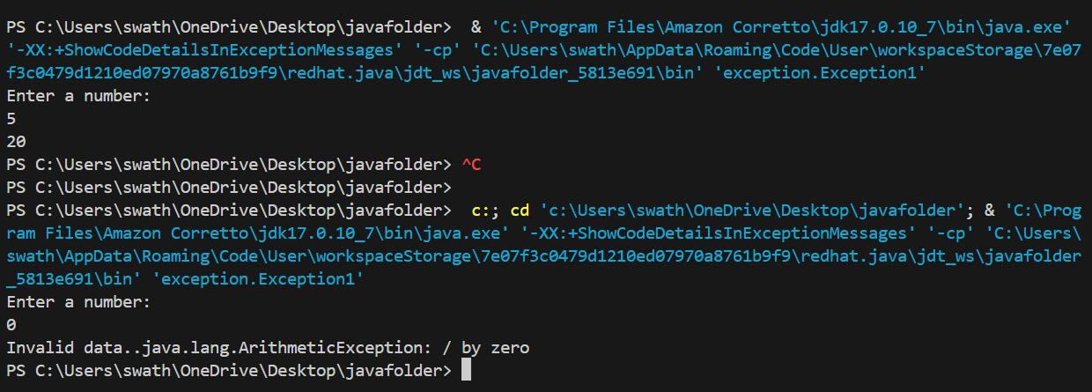

5Q.A

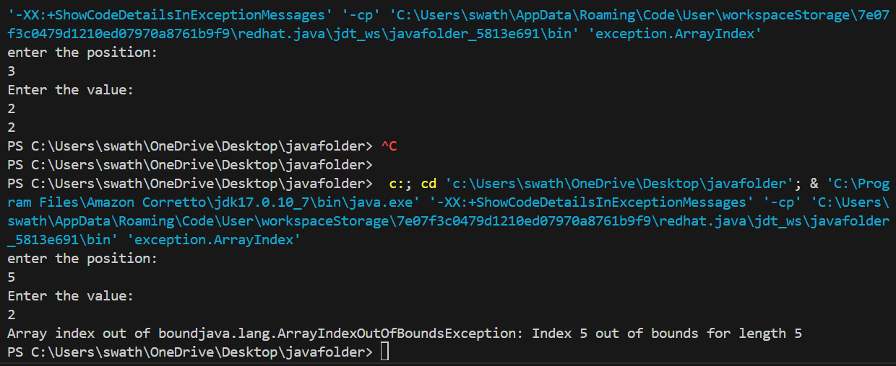

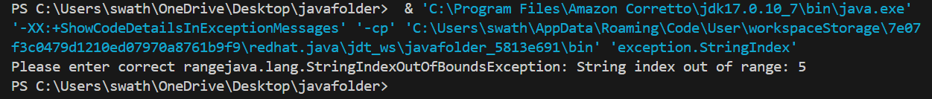

7Q.A

Output:

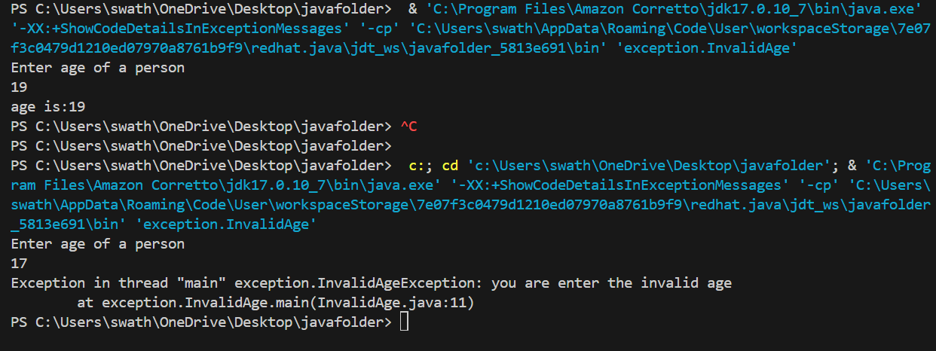

8Q.A

Output:

